**Find out the file and remove it if it exists**

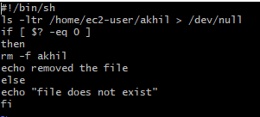

**Filter the files inside a directory and delete them**

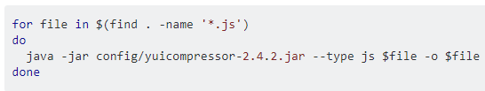

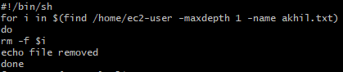

As above, we can also filter with the date or size or modified date by using find command and delete them

**Function example:**

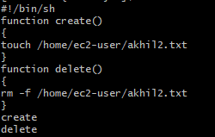

**Function example with switch statement**

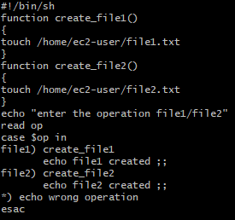

**-z option:**

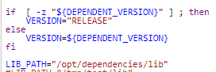

* We can pass any condition if a variable has null value as above.

**To kill the process:**

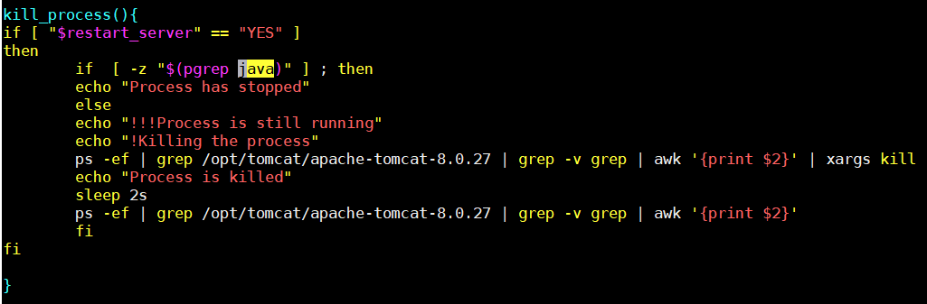

**We can also use variables as below:**

* Add variables as below

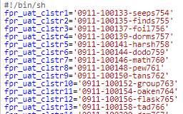

* Then we can use it as below.

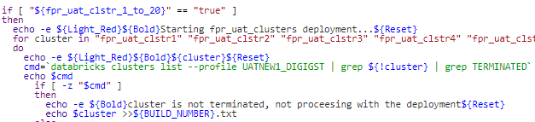

**Immutable variables:**

